Scottish Ensemble put Wellness Centre Stage with Free Events in Partnership with Maggie’s and announce First Light featuring Guest Director Max Baillie
- SE put wellness centre stage as they launch Breathe: Music and Your Mind with Maggie’s
- Three free, hour long events will take place online on 28 & 30 March
- SE welcome Max Baillie as Guest Director for new filmed concert First Light premiering on 29 April 2021
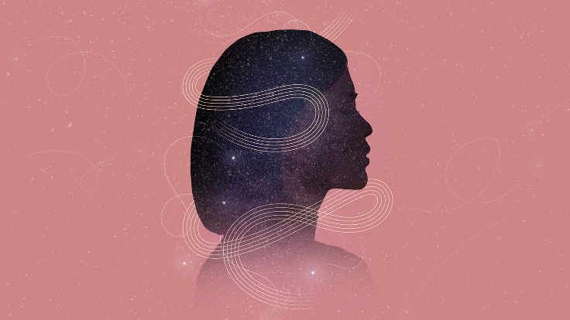
- First Light will feature music by Haydn, Vivaldi, Jessie Montgomery, Steve Martland and Max Baillie

Scottish Ensemble is putting wellness centre stage with brand new events aimed at enhancing wellbeing through both music, and techniques and tools aimed at helping people find calm.
At a time when so many are struggling in terms of their mental health - coping with working from home, home-schooling, loneliness and even bereavement - SE launch Breathe: Music and Your Mind with Maggie’s, three events inspired by their longstanding relationship with the charity.
Supporting and developing their brilliant work with people with cancer and their families by bringing live music into their centres, which they have been doing since 2016, SE are taking their music and mindfulness sessions online with three free, one-hour events on Sunday 28 March at 3pm and Tuesday 30 March at both 2pm and then again at 5.30pm.

The ensemble will continue to share its trademark music for strings alongside reflections from Maggie's Lead Psychologist, Lesley Howells, on how we can all use music in our daily lives to help us feel better. Listening to music is one of the easiest ways to enhance well-being and the ensemble are encouraging audiences from all over the world to join them in escaping the rigmarole of the daily grind and restrictions and to help restore focus in an undeniably tumultuous world.

Young people’s mental health is also at risk due to the pressures and anxieties stemming from the pandemic, so the ensemble has also programmed a Maggie's event for schools on Monday 29 March at 12.30pm. Like the events for adults yet tailored to the needs of school age children (years P6-S6) this event will address the types of stresses these young people might be encountering, while perhaps also introducing them to new music.

With the increase in pressure on everyone’s mental health, we could all do with taking some time out for ourselves and these special performances will help viewers find new ways to listen and give them a taste of how to channel music to sweep away daily pressures.

William Norris, Interim Chief Executive at Scottish Ensemble said: “These free events give people a much-needed opportunity to switch off, step back, and put their own wellbeing centre stage. Maggie's Centres are at the forefront of the quest to improve mental wellbeing with music and conversation, and the way they resiliently continue to improve the lives of so many every single day is truly inspiring. We're delighted to be working with them again to help bring the soothing and stress-relieving power of music to as many people as possible, and can’t wait to see what this partnership brings in the future.”

In addition to these events, Scottish Ensemble continue to promote innovation and collaboration with 2021 digital programme as they announce new film First Light with celebrated Guest Director Max Baillie.
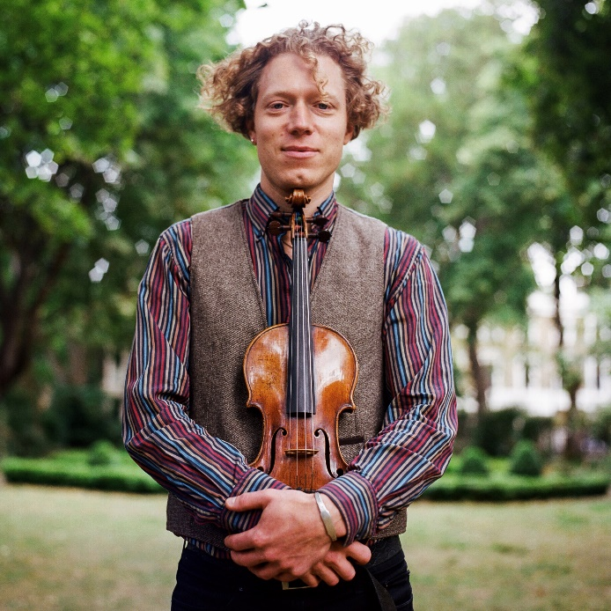
Premiering online on Thursday 29 April at 7.30pm (and available to view online thereafter for ticket holders until midnight on Monday 7 August) First Light is a collaboration between SE and self-described cross-pollinator, soloist, chamber musician, improviser and member of Lodestar Trio and ZRI, Max Baillie.
First Light is an uplifting concert featuring works by Haydn, Vivaldi, Jessie Montgomery, Steve Martland and Max Baillie himself, performed by SE musicians Kate Suthers, Kana Kawashima, Tristan Gurney, Laura Ghiro and George Smith on violin, Jane Atkins and Andrew Berridge on viola, Alison Lawrance and Naomi Pavri on cello, Diane Clark on bass and Jan Waterfield on the harpsichord.
Bringing life and energy to audiences via their screens, First Light signals the transition from darkness to brighter times and Max will lead viewers on a journey through joyful, uplifting and optimistic music, bursting with luminosity.

From Jessie Montgomery's explosive Starburst, through the tempestuousness of a new string ensemble arrangement of Haydn's ‘Fifths string quartet to Vivaldi's vivacious Concerto Grosso in G minor, the programme presents a visual and sonic dialogue between old and new, between the human and the natural, between darkness and light.
Working with Flux Video to create a striking film, Scottish Ensemble invite audiences old and new to join them online to re-energise. Created under Covid-secure conditions First Light was filmed in the Engine Works, Glasgow; a venue that brings the tradition of Glasgow’s proud industrial history and blends it with a modern, contemporary and visionary concept.

William Norris, Interim Chief Executive at Scottish Ensemble, said: “First Light symbolises the transition that we are all going through right now, both in terms of slowly coming out of restrictions and also the changing of the seasons. Max brings a unique creative flare to everything he does, and his music-making reflects our values around innovation, reaching new audiences and promoting cross pollination of sounds and styles; it has been a privilege to have worked with him. We really hope our audiences, both new and existing, enjoy tuning in.”

Max Baillie, First Light Guest Director, said: “It was an absolute pleasure working with Scottish Ensemble to create First Light, which to me symbolises positivity and hope as we look towards spring and the rest of 2021. We have all had to adapt over the past 12 months and to be able to work with such a forward thinking, adaptable and innovative organisation was a hugely refreshing and rewarding experience. I really hope that audiences the world over enjoy First Light as much as I enjoyed making it.”

ENDS

First Light Ticket Details
Single ticket: £10 (+b/f of £1.37)
Household ticket: £20 (+b/f of £2.15)
Available from www.scottishensemble.com

First Light Credits
Filmed at the Engine Works, Glasgow by Flux Video
DOP / Director: Richard Watson
Music Director: Max Baillie
Music Recording and Mixing: Jonathan Green
Camera Operators: Stuart Edwards, Ray Bird

Scottish Ensemble
Director / Violin: Max Baillie
Violin: Kate Suthers, Kana Kawashima, Tristan Gurney, Laura Ghiro, George Smith
Viola: Jane Atkins, Andrew Berridge
Cello: Alison Lawrance, Naomi Pavri
Bass: Diane Clark
Harpsichord: Jan Waterfield

Made possible with support from:
Creative Scotland
Glasgow City Council
RPS Audience Fund in association with the Rachel Baker Memorial Charity

Eternity’s Sunrise by Steve Martland
By arrangement with Schott Music Ltd.

“Starburst” by Jessie Montgomery

About Max Baillie
A graduate of the Yehudi Menuhin School, Cambridge University, and Berlin's UdK, British-German violinist and violist Max Baillie is sought after as soloist, chamber musician, and orchestral leader in the UK and abroad.
His musical life reflects his interest in the cross-pollination of musical styles, having led Bjork’s string orchestra in the Royal Albert Hall, recorded with guitar maestro John Williams, and dueted with Bobby McFerrin in New York. From folk tunes in the Welsh hills to major festivals across the world, Max leads a chameleonic life embracing classical, improvisation, and appearances on stages big and small.
Max plays in ZRI, a quintet drawing together the folk and gypsy influences in works by Brahms, Schubert, and Janacek, and which was inspired by the Red Hedgehog Tavern: a Viennese gateway to the East as well as a favourite drinking hole. Together they have played at festivals across the UK and in Europe and most recently appeared as featured artists and on Swiss radio at the Boswil Sommerfest. They also tour their own live score to Charlie Chaplin's early classic 'The Adventurer'.
Max also founded Lodestar Trio with stars of the Scandinavian folk scene Erik Rydvall and Olav Mjelva, exploring Baroque music through the meeting of violin, Swedish nyckelharpa, and Norwegian hardanger fiddle. Max is a regular at chamber music festivals, which in the last few years have included SoNoRo in Romania and Italy, Lawrence Power’s West Wycombe Chamber Music Festival, and plays regular duo concerts with his father, cellist Alexander Baillie, including touring the Brahms Double concerto with national orchestras of South Africa. For almost 10 years Max has played with Notes Inegales, an innovative contemporary music and improvisation group which invites diverse musical guests for each of their club nights near Euston, including regular slots for the London Jazz Festival.
Max regularly leads Swiss chamber orchestra CHAARTS including tours of China and Switzerland, appearing with Mischa Maisky, Gabor Takacs-Nagy, and Fazil Say, and recording for Sony. He also looks forward to leading the Baroque ensemble Arcangelo at the Barbican this April in London.
Max is working on an album of his own electronic music, plays the mandolin, and has a Political Philosophy degree from Christ’s College, Cambridge.

About Maggie’s
Built alongside NHS hospitals, Maggie’s centres are warm and welcoming places, with qualified professionals on hand to offer an evidence-based core programme of support that has been shown to improve physical and emotional wellbeing.
Maggie’s relies on voluntary donations to develop its unique, high quality programme of support. The charity’s aim is to make the biggest difference possible to people living with cancer and their family and friends.
To find out more about Maggie’s and to see how they support people living with cancer across the UK please visit www.maggies.org
- Maggie’s has 25 years of experience providing free cancer support and information in centres across the UK.
- Built in the grounds of NHS cancer hospitals, the centres are warm and welcoming, and are run by expert staff who help people live well with cancer.
- Maggie’s has been supporting people with cancer throughout the coronavirus crisis over the phone, email and online. This support helped people 239,000 times during 2020.
- Maggie’s centres are open to see people by appointment and limited drop ins for those who are visiting hospitals. This support runs alongside our ongoing phone, email and digital support.
- The first centre opened in Edinburgh in 1996. Maggie's now has 24 centres in the UK. There are also three international centres offering Maggie's support.
- Maggie’s is funded by voluntary donations.
- Maggie’s President is HRH The Duchess of Cornwall.
- Maggie's Chief Executive, Laura Lee was awarded a Damehood in 2020 for her services to people with cancer.
- For more information visit maggies.org

About Scottish Ensemble
Scottish Ensemble (SE) is the UK’s leading string orchestra; a core of outstanding string players who perform together under Artistic Director Jonathan Morton. Based in Glasgow, Scotland, SE inspires audiences in the UK and beyond with vibrant performances which are powerful, challenging and rewarding experiences, crossing genres, styles, musical periods and artistic forms to offer fresh perspectives on classical music.
SE regularly collaborates with high-profile guest artists, from trumpeter Alison Balsom and mezzo-soprano Sarah Connolly to cellist Pieter Wispelwey and violinists Patricia Kopatchinskaja and Nicola Benedetti. SE is also becoming increasingly known for its international collaborations with artists from other disciplines, from dance and theatre companies to visual artists. Starting in 2014, their series of annual cross-artform collaborations has so far included immersive projects with visual artist Toby Paterson; Swedish contemporary dance company Andersson Dance; electronic-classical crossover composer Anna Meredith and visual artist Eleanor Meredith; and, Scottish theatre company Vanishing Point.
Alongside performances across Scotland, SE presents concerts across the UK, London and the globe. Recent invitations to tour abroad have resulted in engagements in Taiwan, China, Brazil, the USA and across Europe, performing at prestigious venues from the Shanghai Concert Hall (China) and the John F. Kennedy Center for Performing Arts (USA) as well as festivals including the Edinburgh International, Edinburgh Fringe and Thuringia Bach Festivals.
SE is also committed to expanding the string repertoire, with recent commissions including new works from John Tavener, James MacMillan, Sally Beamish, Martin Suckling and Anna Meredith.

Contact

Company enquiries
Alison Lewis / alison.lewis@scottishensemble.co.uk

Press enquiries
Sarah Drummond / sarah@thecornershoppr.com / 077 4131 6934

