Press Release for Immediate Use

Scottish Ensemble announces Scotland wide Concerts by Candlelight: Music for Warmth and Restoration tour dates from 2 – 8 December 2021
- SE invite audiences to join them at venues across Scotland Concerts by Candlelight: Music for Warmth and Restoration
- Concerts by Candlelight will tour venues in Aberdeen, Inverness, Perth, Dundee, Edinburgh, and Glasgow from the 2 - 8 December 2021
- Led by violinist and director Matthew Truscott Concerts by Candlelight will feature music by Purcell, Julia Wolfe, Biber, Brahms & Schubert

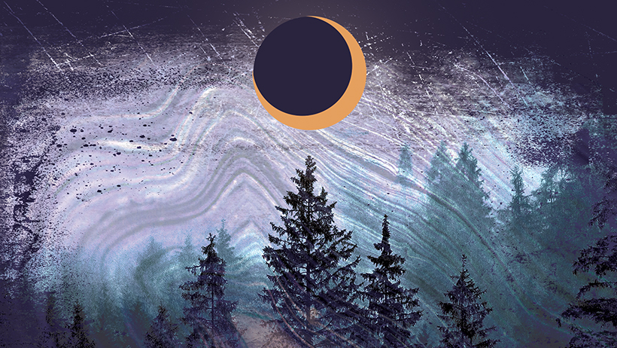

IMAGES HERE

This December Scottish Ensemble will take its annual Concerts by Candlelight on tour to locations across Scotland for the first time since the Covid-19 pandemic.

Taking place at venues in Aberdeen, Inverness, Perth, Dundee, Edinburgh, and Glasgow from the 2 - 8 December 2021, Concerts by Candlelight: Music for Warmth and Restoration is the perfect pre-Christmas musical feast set against a backdrop of shimmering light.

For the first time ever the incisive and dynamic presence of violinist and director Matthew Truscott will lead proceedings and Concerts by Candlelight: Music for Warmth and Restoration will offer something for every taste, with a selection of music spanning centuries, inclusive of a variety of genre and styles.

A web of connectedness binds this string programme around its central work, Beethoven’s taut and beautiful ‘Heiliger Dankgesang’. A song of thanks for recovery from illness it is one of the most celebrated, profound and joyful pieces of string music from any period, and its intimations of past, present and future make it a very fitting tribute to the past 18 months, as we emerge into the ‘new normal’ and enjoy live music all together, once again.

From the gorgeous musical balm of Henry Purcell to the warmth and generosity of Brahms, the touching music by Biber, and the thick, treacly sonic textures of Julia Wolfe’s Four Marys, wherever you are in Scotland this winter, Concerts by Candlelight is the perfect outing for both families and friends.

Violinist and director Matthew Truscott said: “I am very much looking forward to working with Scottish Ensemble to help bring some warmth and restoration to audiences across Scotland with Concerts by Candlelight this December. The programme features music that channels sentiments of courage and overcoming adversity, which seems fitting this year, and I can’t wait to perform in front of live audiences in Scotland once again.”

ENDS

Contact

Company enquiries: Monica Gowans / monica.gowans@scottishensemble.co.uk
Press enquiries: Sarah Drummond / sarah@thecornershoppr.com / 077 4131 6934

Concerts by Candlelight Ticket Details

2 December - St Machar’s, Aberdeen
3 December - Inverness Cathedral, Inverness
4 December -St John’s Kirk, Perth
6 December - Caird Hall, Dundee
7 December - Greyfriars’s, Edinburgh
8 December - Wellington Church, Glasgow

Available from www.scottishensemble.com

Repetoire

Henry Purcell In Nomine in 7 parts, Dorian
Julia Wolfe Four Marys for string orchestra
Heinrich Biber Balletti Lamentabili a 4
Johannes Brahms Adagio from String Quintet No.2 in G major
Franz Schubert Der Leiermann (The Hurdy-Gurdy Man) from Winterreise (arranged for string orchestra by Dobrinka Tabakova)
Henry Purcell
Symphony and Here the deities from Welcome to all the pleasures
Fantasy on One Note
Ludwig van Beethoven Molto Adagio (Holy song of thanksgiving) from String Quartet No.15
(arranged for string orchestra by Iain Farrington)
Anon In Nomine in 6 parts

About Scottish Ensemble

Scottish Ensemble (SE) is the UK’s leading string orchestra; a core of outstanding string players who perform together under Artistic Director Jonathan Morton. Based in Glasgow, Scotland, SE inspires audiences in the UK and beyond with vibrant performances which are powerful, challenging and rewarding experiences, crossing genres, styles, musical periods and artistic forms to offer fresh perspectives on classical music.

SE regularly collaborates with high-profile guest artists, from trumpeter Alison Balsom and mezzo-soprano Sarah Connolly to cellist Pieter Wispelwey and violinists Patricia Kopatchinskaja and Nicola Benedetti. SE is also becoming increasingly known for its international collaborations with artists from other disciplines, from dance and theatre companies to visual artists. Starting in 2014, their series of annual cross-artform collaborations has so far included immersive projects with visual artist Toby Paterson; Swedish contemporary dance company Andersson Dance; electronic-classical crossover composer Anna Meredith and visual artist Eleanor Meredith; and, Scottish theatre company Vanishing Point.

Alongside performances across Scotland, SE presents concerts across the UK, London and the globe. Recent invitations to tour abroad have resulted in engagements in Taiwan, China, Brazil, the USA and across Europe, performing at prestigious venues from the Shanghai Concert Hall (China) and the John F. Kennedy Center for Performing Arts (USA) as well as festivals including the Edinburgh International, Edinburgh Fringe and Thuringia Bach Festivals.

SE is also committed to expanding the string repertoire, with recent commissions including new works from John Tavener, James MacMillan, Sally Beamish, Martin Suckling and Anna Meredith.

