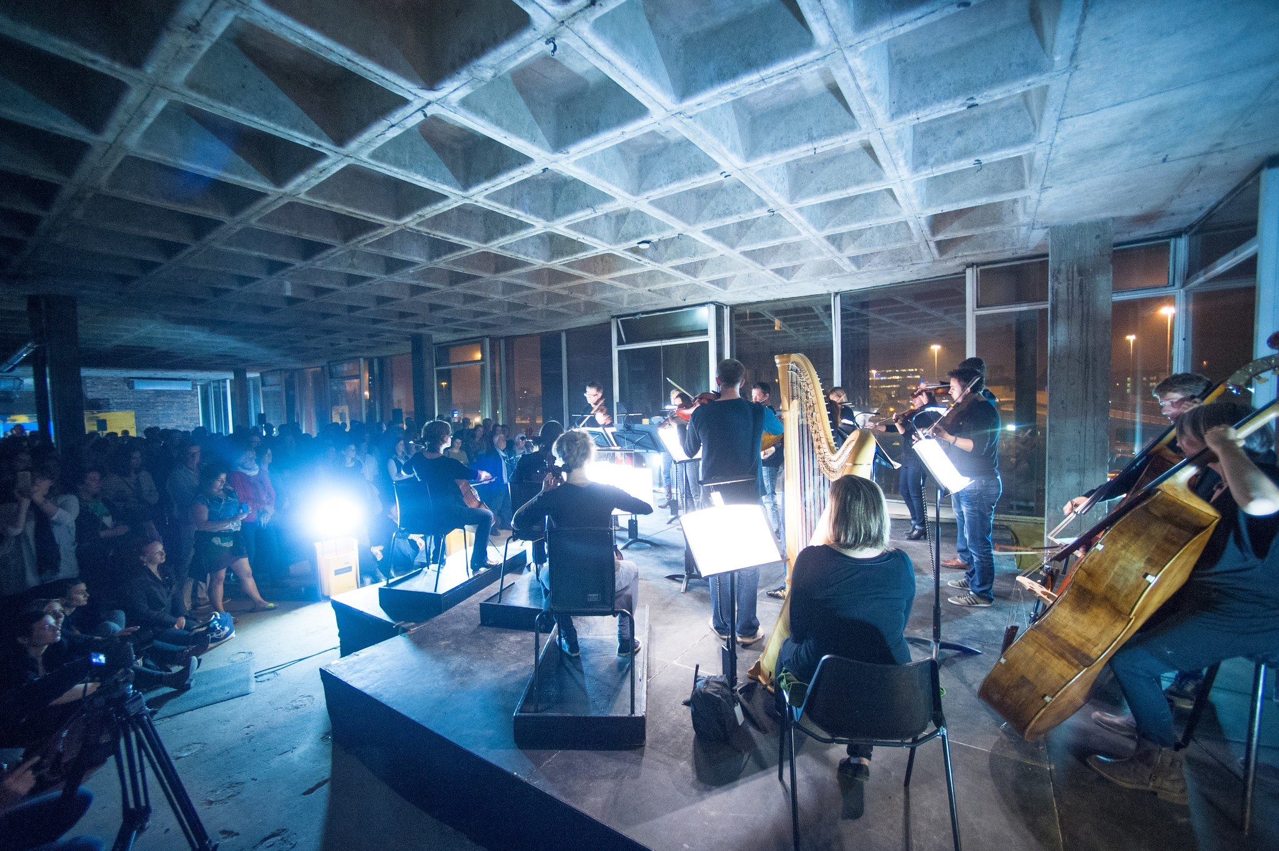
Marketing & Communications Manager
Role Description

Scottish Ensemble – Marketing & Communications Manager
Role and Person Specification
Introduction
Scottish Ensemble – one of the UK’s most inventive and forward-thinking classical ensembles – is seeking a new Marketing & Communications Manager.
Our reputation for innovative cross-artform collaboration, engaging filmic content, and meaningful work on well-being and mental health continues to grow, and this key role will help us maximise our impact and reach. You will be responsible for driving audiences (and box office revenue) across Scotland and beyond, for all our live and digital work.
The successful candidate will be part of a small, collaborative, and creative team, each of whom plays a crucial role in realising the ambitions of Scottish Ensemble.
We are looking for a post-holder who can both be innovative in how they talk about and sell our work, but also ensure that marketing strategies are underpinned by robust systems and evaluation. Supported by a Marketing Assistant and a Digital Content Producer, you will both conceive and deliver all core marketing activities in the organisation and so we are seeking someone who is a creative and fast thinker – someone who excels in a role that is both strategic and practical.
Equally importantly, we are looking for someone who identifies with and is excited by Scottish Ensemble’s mission and philosophy and who can relay this excitement to audiences current and potential. You will understand the motivations of current audiences but also be able to identify what the barriers to attendance might be for non-attenders.
If you are excited by this opportunity, we look forward to hearing from you.
If you would like an informal chat with CEO Jenny Jamison about the role, please email jenny.jamison@scottishensemble.co.uk and we’ll be happy to arrange a call.

Scottish Ensemble Biography
Scottish Ensemble (SE) is the UK’s leading string orchestra; a core of outstanding string players who perform together under Artistic Director Jonathan Morton. Based in Glasgow, Scotland, SE inspires audiences in the UK and beyond with vibrant performances which are powerful, challenging and rewarding experiences, crossing genres, styles, musical periods and artistic forms to offer fresh perspectives on classical music.
SE regularly collaborates with high-profile guest artists, from trumpeter Alison Balsom and mezzo-soprano Sarah Connolly to cellist Pieter Wispelwey and violinists Patricia Kopatchinskaja and Nicola Benedetti. SE is also becoming increasingly known for its international collaborations with artists from other disciplines, from dance and theatre companies to visual artists. Starting in 2014, their series of annual cross-artform collaborations has so far included immersive projects with visual artist Toby Paterson; Swedish contemporary dance company Andersson Dance; electronic-classical crossover composer Anna Meredith and visual artist Eleanor Meredith; and Scottish theatre companies Vanishing Point and Untitled Projects.
Alongside performances across Scotland, SE presents concerts across the UK, London and the globe. Recent invitations to tour abroad have resulted in engagements in Taiwan, China, Brazil, the USA and across Europe, performing at prestigious venues from the Shanghai Concert Hall (China) and the John F. Kennedy Center for Performing Arts (USA) as well as festivals including the Edinburgh International, Edinburgh Fringe and Thuringia Bach Festivals.
SE is also committed to expanding the string repertoire, with recent commissions including new works from John Tavener, James MacMillan, Sally Beamish, Martin Suckling and Anna Meredith.

Scottish Ensemble Mission
To create exhilarating musical experiences that forge new connections between people, places and ideas.
Scottish Ensemble Core Values
1) We believe that music is a highly flexible and collaborative art form that can and should make meaningful connections across repertoire, genre, form and discipline.
2) We want to create opportunities for musicians to explore and stretch their musicianship, creative and communicative skills, to ensure they are continually developing as artists and as ambassadors for music-making.
3) We believe that classical music can be as connected to current audiences, communities and artists as it is to its great, centuries-old traditions, but only when boundaries and conventions are reassessed.
4) We celebrate Scotland’s diversity and create work to build strong connections across the length and breadth of the country, but also aspire to share our work with international audiences.
5) We are responsible global citizens who use resources in a socially and environmentally conscientious way.
6) We believe that technology can enable us to explore new artistic opportunities and to share our performances and creative learning work with as wide an audience as possible.

Marketing & Communications Manager: Role Description
Key information
Job Title | Marketing & Communications Manager
Hours | Full time (35 hours/week) + evenings and weekends during touring projects as required (TOIL granted in accordance with company policy)
Location | CCA, 350 Sauchiehall Street, Glasgow G2 3JD
Reports to | Chief Executive
Manages | Marketing Assistant  Digital Content Producer
Key terms | - Salary £30,000/annum  - 22 days annual leave + public holidays  - Auto-enrolment into SE’s contributory pension scheme (it is possible to opt out of this)  - To start as soon as possible (dependent on any relevant notice periods with current employer)  - Flexible conditions (eg. partial working from home, flexi-hours)
Role purpose and role dimension | To develop and grow SE’s brand, profile, reach, audience diversity and audience numbers through leadership of all SE’s marketing initiatives (including digital).
Key external contacts | - SE audiences and stakeholders  - Marketing teams working at our partner venues and for external promoters/festivals etc  - Print, design, and multimedia companies  - Arts journalists
Key internal contacts | - CEO  - Artistic Director  - Marketing Assistant  - Development Lead  - SE project managers  - SE performers
Financial dimensions | Responsibility for marketing budget and monitoring all marketing expenditure.
Key areas for decision making | Marketing and brand strategy, audience development, and digital strategy in consultation with CEO; plus marketing partnerships and planning.

Role Scope
Key Result Areas | Key Tasks | % of time
Brand and Strategy | - Leading on the ongoing development of a bold, distinctive brand for SE, which appeals and speaks effectively to a diverse audience  - Leading on development of SE’s marketing strategy in the context of wider organisational business planning (as well as the marketing sections of SE’s applications to Creative Scotland), in consultation with the CEO  - Planning and monitoring expenditure within the set annual and project marketing budgets  - Leading on audience development initiatives and evaluation  - With the CEO, setting and monitoring ticket sale and audience engagement targets  - Collaboration with the full SE team to ensure close integration of programming, fundraising and marketing objectives | 25%
Content creation | - Commissioning and/or copywriting for all key printed marketing assets (season brochure, posters, flyers, programmes etc.)  - Working with designers on the creation of the marketing assets  - Producing/commissioning and editing written digital content (see also Digital & Website)  - Proofreading | 20%
Marketing and distribution | - Developing and implementing a marketing plan for all SE performances  - Oversee the Marketing Assistant in arranging and co-ordinating all distribution and direct mail campaigns  - Overseeing ticketing and box office systems with external partner box offices  - Developing reciprocal marketing partnerships  - Liaising regularly with designers, printers and distribution companies  - Identifying distribution opportunities to widen SE’s reach | 20%
Digital & Website | - With the CEO, exploring digital innovation and devisingthe organisation’s digital marketing strategy  - With the Marketing Assistant, day-to-day website maintenance  - With the Digital Content Producer and CEO, planning the release and distribution of SE’s digital content (incl. films, recordings and streams)  - Leading on social media planning and content  - Writing and planning regular e-flyers and updates, delegating where appropriate | 20%
Press & PR | - Briefing and generating content for press releases, and managing the relationship with external PR consultant  - Maintaining and building relationships with national, regional and local press and media | 10%
Other | - Attendance at SE concerts, and oversight of FOH operations at concerts (these responsibilities are shared with the Marketing Assistant – you will not be required at every performance)  - Some simple touring logistics support when SE is on tour  - Line management of Marketing Assistant | 5%

Person Specification

Essential knowledge, skills and experience | - Minimum three years’ experience of working in a marketing role  - Thorough practical understanding of marketing tools and procedures (offline and digital)  - Experience of PR, including an understanding of what makes a good press story  - Experience of managing budgets  - A skilled copywriter, able to convey the key selling points of a programme, and to tell a story about it, to an array of different audiences  - Demonstrable success in attracting new audiences or increasing attendance from irregular attenders  - Ability to understand the needs and motivations of different audiences (current and potential) and create campaigns tailored for them.  - A high level of creativity and an ability to devise novel solutions and strategies, while using data to evaluate success  - Understanding of the importance of brand and tone of voice  - Interest in classical music
Desirable knowledge, skills and experience | - Experience of working in a music organisation  - Experience of leading and/or implementing marketing and audience development strategies  - Strong IT skills, particularly MS Office and management of CRM systems (SE uses ThankQ)  This role is flexible depending on the candidate. Elements of the job description could be out-sourced or delivered in-house depending on the successful candidate’s particular skillset. Therefore, certain key skills could bring added value, including:  - Graphic design skills  - Film production skills  - Creative writing skills
Desirable attributes | - Demonstrable experience of managing a busy and varied workload and achieving objectives  - First-class communication and interpersonal skills  - Meticulous attention to detail  - High levels of self-motivation and ability to work independently with a strong collaborative teamwork ethic  - Ability to build positive and constructive relationships with internal and external contacts  - A well-networked individual who is engaged with the cultural sector and who is aware of major developments within it
Special conditions | - Applicants must be able to regularly attend concerts and events across Scotland outside of normal working hours as required by the company’s touring schedule. Time off in lieu is granted in line with SE’s TOIL policy.  - Applicants must be eligible to work in the UK

While the above specification represents our ideal mix of skills and experience for the role, we welcome applications from those meet a majority, but not all, of the skills/experience outlined.
How to apply
To apply, send your CV, accompanied by a cover letter of no more than 2 pages (all saved as one document) outlining why you are interested in the position and how you meet our role requirements, to monica.gowans@scottishensemble.co.uk by 5.30pm on Friday 12 August. You may send a video or audio recording in place of a cover letter if you wish.
As part of our commitment to a fair recruitment process, we ask that you remove names of any educational establishments you have attended from your CV and cover letter. All applications will be anonymised before shortlisting occurs.
Interviews will be held during the week beginning 15 August 2022.
We also request that you complete our Equal Opportunities Monitoring Form – all data is gathered anonymously.

