Press Release for immediate use
Scottish Ensemble & Social Bite serve up the perfect slice of summer with new Sound Bites collaboration
- Scottish Ensemble teams up with Social Bite to bring the flavour of the Four Seasons to upcoming outdoor music festival Live at No.40
- Sound Bites celebrates the joy of sharing food and listening to music with others as we emerge from lockdown
- Sound Bites was developed through shared commitment to engaging with new audiences and supporting the local and homeless communities
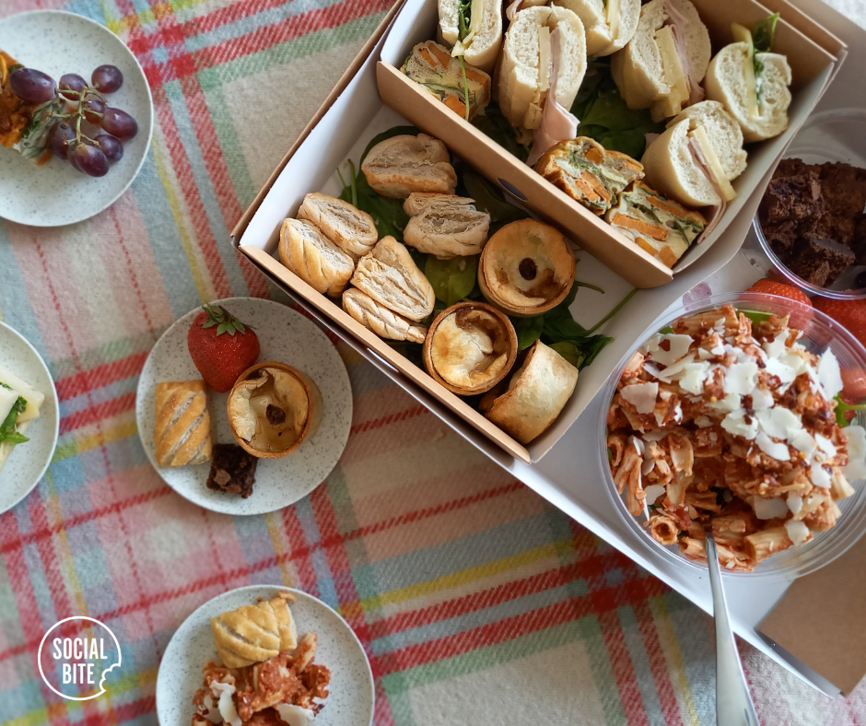
Scottish Ensemble (SE) and Social Bite are teaming up this summer to spread the joy of shared food and live music with new collaboration Sound Bites.
Based on the notion that these simple pleasures are at the heart of peoples’ lives as social beings, Sound Bites connects the worlds of food and music with a themed picnic box available for audience members to enjoy during upcoming performances as part of month-long outdoor festival Live at No.40.
Scottish Ensemble will bring to life Vivaldi’s iconic masterpiece, The Four Seasons, as audiences enjoy a bespoke picnic of handmade goodies sprinkled with a touch of the Four Seasons by Scottish charity and social enterprise Social Bite. Each picnic basket will contain a duo of tasty baguettes with two different fillings, and depending on dietary preference, a selection of pies, frittatas, sausage rolls, salads and even some of Social Bite’s famous brownie bites.
In solidarity with the Social Bite cause to end homelessness and in keeping with its reputation for thinking outside the (picnic) box, 10% of ticket sales for Scottish Ensemble performances are being donated to Social Bite and its work helping and supporting some of the most vulnerable individuals and communities across Scotland and the UK.
Taking place from the 3 July to 1 August 2021, Live at No.40. will unfold at Scottish Opera’s Production Studio car park at 40 Edington Street, Glasgow. Joined by Scottish Opera and Citizens Theatre in a specially created outdoor theatre, Scottish Ensemble will perform four concerts over two days, accompanied by Scottish charity and social enterprise Social Bite.
At a time when the country is cautiously celebrating new beginnings, Vivaldi’s works of art speaks poignantly to disruption and the inevitability of change with piercing precision. By bringing audiences together, not only for possible the first live performance in over a year, but to ‘break bread’ with fellow music lovers, friends and family, SE and Social Bite mark an important milestone during a turbulent time.
William Norris, Interim Chief Executive at Scottish Ensemble, said: “One of the things we've all missed in the last year has been sharing. Sharing time with friends. Sharing experiences. Sharing food. Sharing music. Our Sound Bites performances of Vivaldi's ever-green Four Seasons promise to provide all of the above, but also share a portion of everyone's ticket purchase with our partners in this project, Social Bite, who do incredibly important work in tackling homelessness. We're really excited to be partnering with them on this project which marks our return to live performance in a characteristically different way.”

Co-founder and CEO of Social Bite, Josh LittleJohn MBE said: “This collaboration will not only be a brilliant celebration of enjoying food, drink and music together, something we’ve all missed over the past year, it’s also an opportunity to bring about real positive change. This fantastic event will deliver funding to our innovative programmes that support people out of homelessness and help them to build independent lives.
We hope everyone who joins us at Sound Bites enjoys the performance, along with our delicious picnics - specifically crafted for this event by our talented kitchen staff of which 1/3 have come from a background of homelessness. Thank you for your support and for joining us in our mission to ensure everyone has a safe place to call home.”
ENDS
Ticket Details
Tickets are available from £12 can be booked online: https://www.trybooking.co.uk/BCKP
On sale from 10am on 8 June 2021.

Picnic Details
Picnics should be booked with tickets and are priced at £7.99. They are available to reserve until 13 July.

Contact
Company enquiries
Alison Lewis / alison.lewis@scottishensemble.co.uk
Press enquiries
Sarah Drummond / sarah@thecornershoppr.com / 077 4131 6934

About Scottish Ensemble
Scottish Ensemble (SE) is the UK’s leading string orchestra; a core of outstanding string players who perform together under Artistic Director Jonathan Morton. Based in Glasgow, Scotland, SE inspires audiences in the UK and beyond with vibrant performances which are powerful, challenging and rewarding experiences, crossing genres, styles, musical periods and artistic forms to offer fresh perspectives on classical music.
SE regularly collaborates with high-profile guest artists, from trumpeter Alison Balsom and mezzo-soprano Sarah Connolly to cellist Pieter Wispelwey and violinists Patricia Kopatchinskaja and Nicola Benedetti. SE is also becoming increasingly known for its international collaborations with artists from other disciplines, from dance and theatre companies to visual artists. Starting in 2014, their series of annual cross-artform collaborations has so far included immersive projects with visual artist Toby Paterson; Swedish contemporary dance company Andersson Dance; electronic-classical crossover composer Anna Meredith and visual artist Eleanor Meredith; and, Scottish theatre company Vanishing Point.
Alongside performances across Scotland, SE presents concerts across the UK, London and the globe. Recent invitations to tour abroad have resulted in engagements in Taiwan, China, Brazil, the USA and across Europe, performing at prestigious venues from the Shanghai Concert Hall (China) and the John F. Kennedy Center for Performing Arts (USA) as well as festivals including the Edinburgh International, Edinburgh Fringe and Thuringia Bach Festivals.
SE is also committed to expanding the string repertoire, with recent commissions including new works from John Tavener, James MacMillan, Sally Beamish, Martin Suckling and Anna Meredith.

About Social Bite
Social Bite started as a sandwich shop on Rose Street in Edinburgh in August 2012 and has now grown to a major driving force in tackling homelessness in Scotland and further afield. One in 3 of Social Bite’s staff have a background of homelessness and the charity has received visits from Hollywood superstars Leonardo DiCaprio and George Clooney.
Social Bite is the largest distributor of free fresh food to the homeless in the UK, giving out more than 140,000 items of food and hot drinks per year. In response to the recent pandemic, more than 800,000 emergency food packs and essential items were distributed.
Social Bite’s 2017 and 2018 Sleep in Park events in Scotland raised almost £8million and saw more than 18,000 people sleeping out. With funds raised from Sleep in the Park events, The Social Bite Village was built in May 2018 and 39 people have since been housed in the bespoke accommodation. The charity also launched a nationwide program to bring 830 rough sleepers off the streets into their own accommodation with support. More than 400 people have now been housed and counting.
In 2019, the charity’s founder Josh Littlejohn MBE created The World’s Big Sleepout, which was a global campaign to raise awareness of homelessness. The campaign saw 60,000 members of the public Sleepout in 52 cities all over the world and was supported by Will Smith and Dame Helen Mirren.
The Social Bite Fund (SC045232) is a registered charity in Scotland which seeks to alleviate homelessness through innovative solutions from employment and support programmes, to temporary housing.

